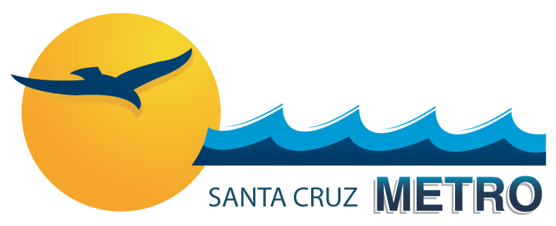

YOUTH ART POSTER CONTEST 2017
“May The Bus be with You!”

FOR: Santa Cruz County Children Up to 14 Years of Age.
START: Monday, September 11, 2017
FINISH: Tuesday, October 31, 2017

- Children must create their own original artwork. (NO clip art, computer-generated graphics, or copyright protected characters.)
- Poster should reflect the theme: “May The Bus be with You!”
- Must be submitted on 10” x 17” quality paper or poster board.
- Must be 2-Dimensional
    - Paint, Crayon, Marker, Colored Pencil Acceptable.
    - NO glued on pieces or bubble paint.
- One Entry per Child.
- Securely Affix (tape or glue) Entry Form to Back of Poster.
- Deliver entries in person to the METRO Customer Service Booth inside the Transit Center at:
  - SCMTD Watsonville Station: 475 Rodriguez Street, Watsonville CA 95076
  - SCMTD Pacific Station: 920 Pacific Avenue, Santa Cruz, CA 95060
    - MAIL ENTRY TO: METRO Art, 920 Pacific Avenue, Ste. 21, Santa Cruz, CA 95060

JUDGING CRITERIA:
- Illustrating the Theme (May The Bus be with You!)
- Creativity & Originality
- Overall Visual Appeal

WINNERS:
- Best of Show wins Headways Front Cover!
- 1st 2nd 3rd Place Winners for: Ages 6 and Under
Ages 7 to 9
Ages 10 to 14
- 1st Place Winners’ Artwork displayed on METRO bus exteriors.
- 2nd and 3rd Place Winners’ Artwork displayed inside METRO vehicles.
- Winners will be notified by telephone/mail on or before November 14, 2017.

QUESTIONS? Call METRO Customer Service: (831) 425-8600

OFFICIAL ENTRY FORM

YOUTH ART POSTER CONTEST 2017
“May The Bus be with You!”

(Please type or print clearly using blue or black ink)

Childs Name: Age:
Street Address:
City: State: Zip Code:
Phone Number (include area code):
Parent or Guardian Name

I hereby certify that this poster was created entirely by the child above and is the child’s original artwork. I agree that it may be offered for public display or publication during or after the contest. I understand that this poster becomes the property of the Santa Cruz METRO and may be reproduced. The only information that will be released is the child’s name and age.

Child’s Signature:

Parent/ Guardian Signature:

This form must be securely attached to the back of every entry.

Submit to Customer Service Booth

PACIFIC STATION WATSONVILLE
920 Pacific Avenue or 475 Rodriguez Street
Santa Cruz CA 95060 Watsonville, CA 95076

